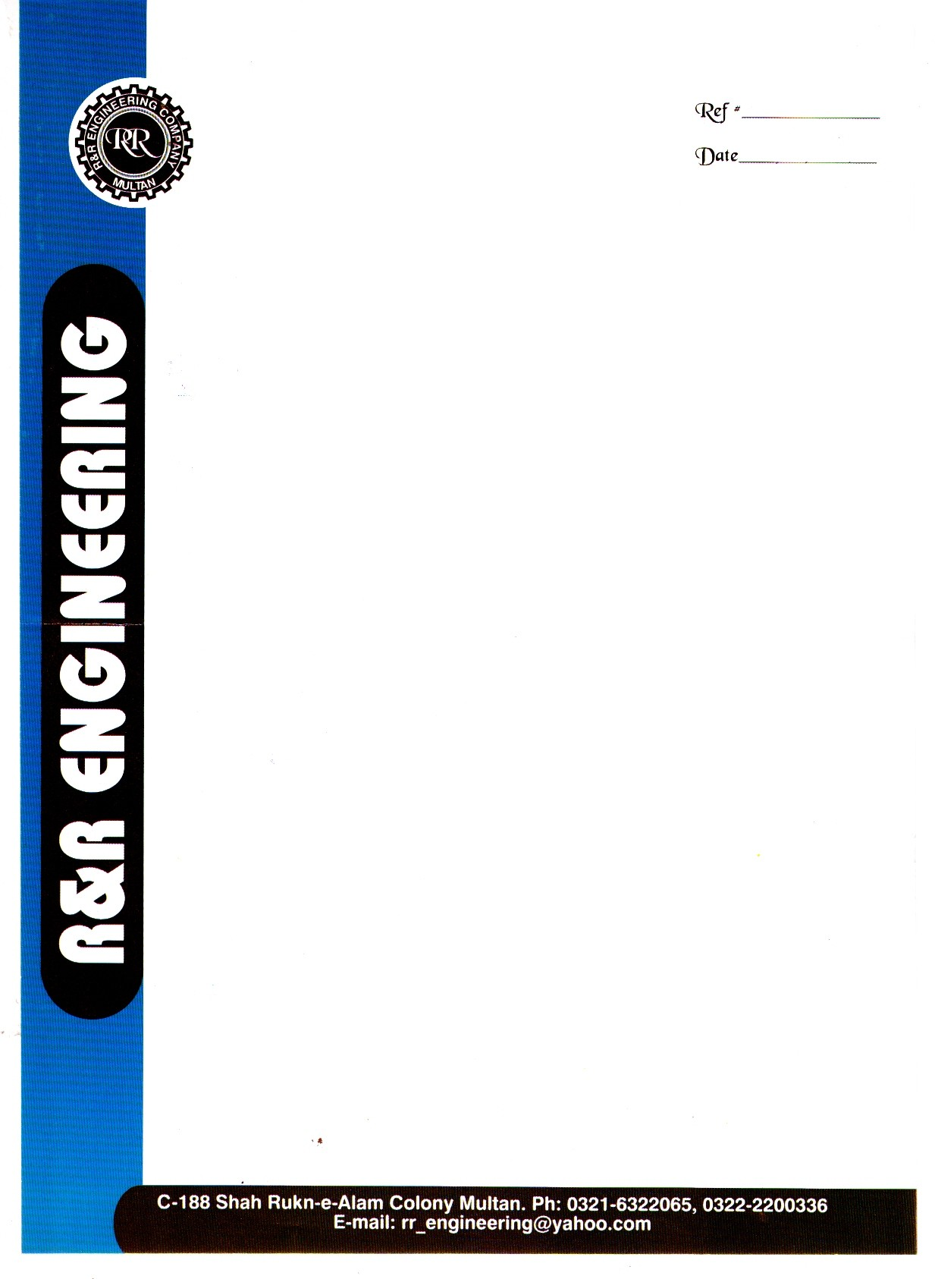

<To>

**TO WHOM IT MAY CONCERN**

This is to certifying that Mr. <Name> S/o <fname> has been working with our organization as <Designation> from <From> to <To> at Pakarab Fertilizer Multan.

During this tenure we found him honest, punctual and hard working young man.

We wish him every success in his future life.

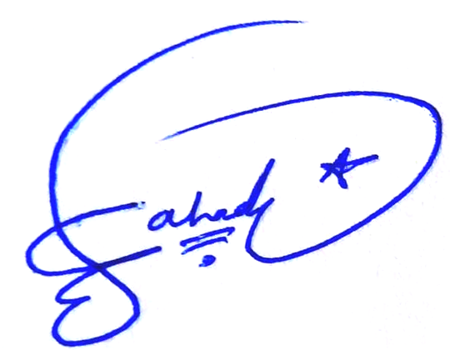

**Project Incharge**